Surprising lighting effects can be achieved in Anim8or version 0.6 scenes with just a little effort. You will find below a few tricks for faking volume light, glow, lens effect and changes in global illumination (color and intensity). All of these effects are animatable.
This is not intended to be a step-by-step tutorial (I assume that you are an Anim8or user), but a guideline and a challenge for your imagination. First look at some images, later I'll describe the "tools" responsible for the effects. If you are passionate about lighting effects, I am convinced you can do much better than me!
Let's try to improve a scene using filters, and I mean almost real objective-lens filters. The Shark-scene, as you can find it in Anim8or's Manual, is down-loadable from Elias Marzane's anim8ortrade.
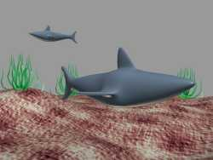 | First, a little make-up by setting a background color for the environment, enabling a partially transparent fog, reorienting the lights and adding a shadow. | 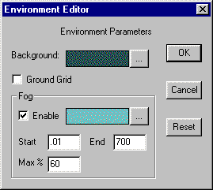
  Initial shark-scene

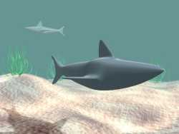 | Now, if we would like to decrease the transparency of the water so that even the foreground shark to be faded and the background one to remain still visible, we couldn't manage it by setting the fog parameters (which already starts from the camera). We need a nonzero origin value for the fog. Placing a tiny neutral filter in front of the camera, | 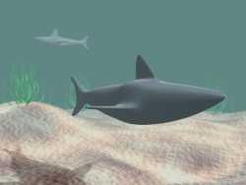
  Shark-scene with fog and shadow
  Neutral filter, adding fog in foreground
covering its whole field, can do this. Setting the transparency of the filter, we adjust the starting value for the fog. Using colored filters, we can change the hue of the image. Our water, even with reduced transparency, seems too limpid, needs some turbidity. It's begging for micro-plankton! So, let's add a spotted filter.
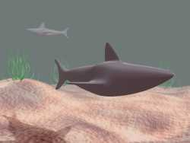 | 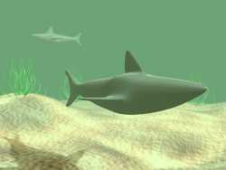 | 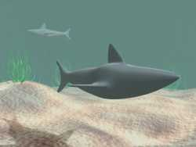
  Shark-scene with red filter
  Shark-scene with yellow filter
  Micro-plankton (seen only in high-res)
Evidently, a single filter object can act as a color filter, transparency filter, texture projector (as the spotted filter does) and so on.
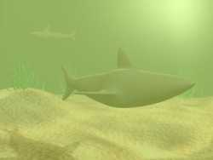 | In order to look great, our scene needs some diffuse light. Let's try a glow filter! It is much better. The glow filter has its own color (yellow) and has an amount of self-illumination (ambient) to light up the image. See the set-up. | 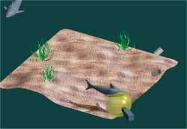
  Shark-scene with glow filter
  Hemispherical glow filter

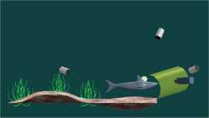 | Now, we remove the glow filter and add volume light, using a cylindrical filter. See the set-up. We have got a more convincing underwater scene. | 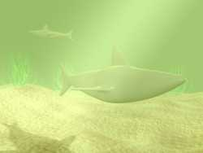
  Tilted cylindrical filter
  Click the image to enlarge

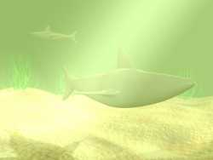 | By changing the material parameters of the filter we can set the volume light effect. | 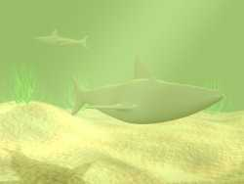
  High specular value filter
  Low specular value filter

Small movements of the filter may afect considerably the image and that is one of the possibilities for animating the effect. | 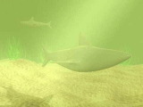
Ending the diving, we are ready to jump right into the fire!

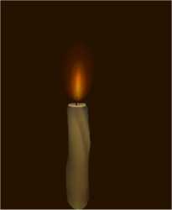 | The candle's flare was done with a shiny surface, user lights and fog, inspired by the superb spectrum effect of Wladyslaw Strugala's rainbow. Adding a glow filter, adding one more, some rays (with a transparent shiny cylinder-made star object) and finally a discrete anamorphic effect (a simple blue | 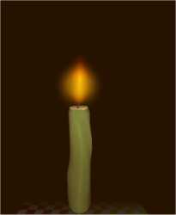
  No filter
  Adding a glow
transparent cylinder), we get a pretty nice lens effect.
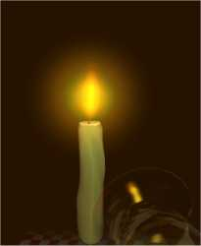 | 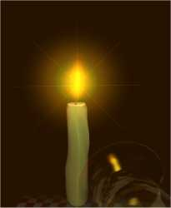 | 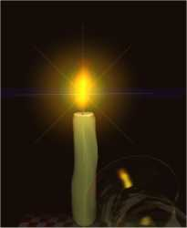
  Adding a second glow
  Adding a ray-device
  Anamorphic Click to enlarge

 | 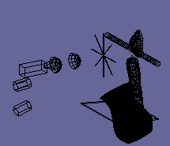 | See on the left the setup of the scene. Moving the candle's flame along with the effects' source objects and using a transparency filter sliding in front of the camera, we are able to animate the effects. Skinning the flame would have given a more realistic look.
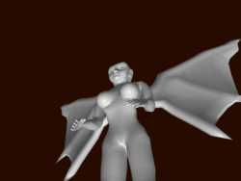 |  |  |  | Robert Watson's Archangel(ess) was downloaded also from anim8ortrade. (Let's say frankly, she is better suited for a nudibar than for the heavens!) We are going to cover her with a gloria. All that we need is glow effect and rays, so let's add a glow filter and a ray device. If you aren't satisfied with the glow, which is superposed over the face, move the glow filter in the background. You may use a glow device in the foreground and one in the background, tuning the effect as you wish!

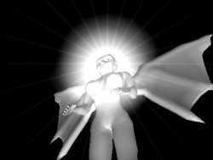 | 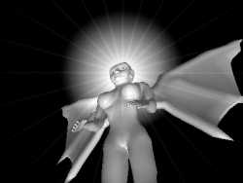 | 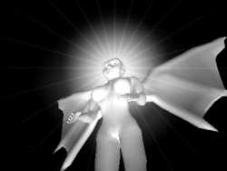
  Foreground glow
  Background glow
  Foreground and background glow

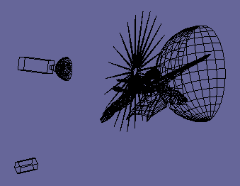 | See on the left the set-up of the scene. Use colors and animate the effect! | 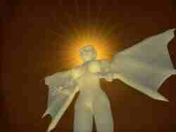
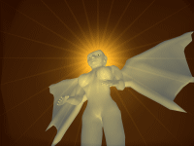

Adding a subtle jet glow to the engines of Enterprise 1701A , found at anim8ortrade, is just a piece-of-cake. We make use of volume light. Notice below the attenuation of the jet and the stars seen through the glow. | 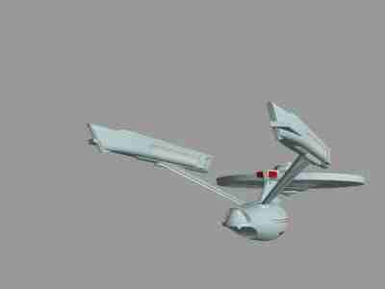

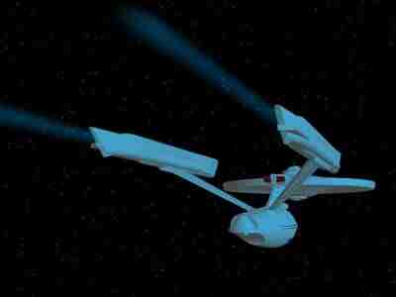 | The main problem with the scene is related to the light used to make the engine glow. The starship gained a bluish color that is not wanted, except the case that Enterprise is passing in the proximity of an O, or B spectral class star. One of the solutions is to shift the colors used for Enterprise in a direction opposed to the light, in the RGB plane. (We used blue light, so we'll shift the colors to yellow) I have also darkened the colors to emphasize the self-illuminations. (See below)

The scene is animatable (the effect-responsible objects move along with the starship) without any change in this setup (see below) as long as Enterprise doesn't change course. | 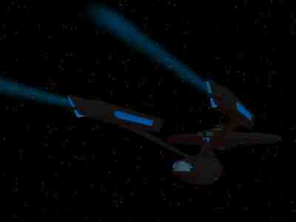
  Click the image to enlarge

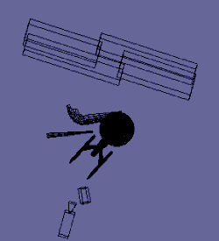 | 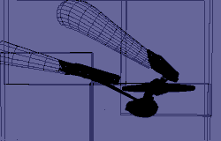

This "spotlight" scene relies on the same type of effect-maker object as the one for the jet-glow, a half-cone. The variation is the use of a second light directed to highlight the rounded end of the cone. You can adjust the intensity of the effect by changing the material parameters of the effect-object.
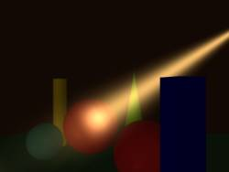 | 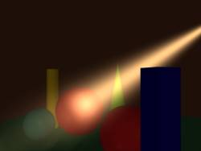 | 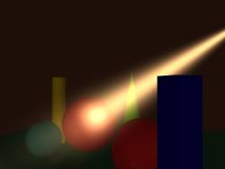

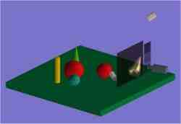 | Moving a variable transparency filter in front of the camera, the level of illumination can be varied up to total extinction. Notice the use of a dark neutral filter for the background objects, placed behind the effect-device, to darken the scene without fading the spotlight and a second transparency filter (lighter) right in front of the camera, for animating the light. | 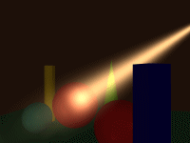
That easy is to simulate the falling of the night. 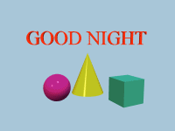

Manufacturing the effect devices

Plane filters
Simple filled rectangles (2D objects) covering the field of the camera. Depending on the material parameters assigned to them, they are uniform filters, or texture projectors. Their effect is visible at edit-time.

Neutral filter
Parameters: Color - a shade of grey (R=G=B)
Transparency - a nonzero value
Us: Darkening the scene (dark grey or black color), or creating fog in the foreground (light grey or white)

Colored filter
Parameters: Color
Transparency - a nonzero value
Ambient
Us: Changing the hue of the image. A nonzero value for Ambient lights up the scene.

Variable transparency filter

It is a combination of neutral filters with different values for transparency. We manufacture it starting from a box with a number of divisions along one of the axes, than cutting half of the vertices to make it a 2D object. In point-edit mode select the faces one by one, assigning them different material parameters (transparency, color)
Us: Sliding the filter in front of the camera we can adjust dynamically the overall illumination (color and intensity) of the scene during the animation.

Texture projector
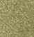
Parameters: Texture - Any kind of image, for example spots, a color gradient
Transparency - a nonzero value
Ambient
Us: Superposing a ghost image over the scene. The sharpness of the image depends on the Transparency and Ambient values and the distance between the camera and the filter (the farther the filter, the sharper the image). It is a simple way for atmospheric effects, like rain, snow falling (but not very realistic), better using a rotating cylindrical filter. It is useful to break the uniformity and unnatural clarity of the space in 3D scenes. The spotted filter for the shark-scene uses a texture painted with a soft airbrush tool with one-pixel spots on a uniform color background. It makes a good job as plankton, but is visible discretely only in high-resolution images.

Curved filters

Glow filter
Parameters: Shape - Mainly spherical
Transparency - Zero (completely transparent)
Specular
Roughness
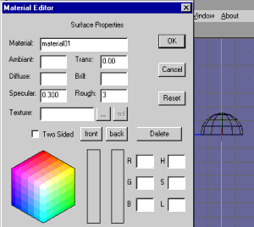
The glow is a rendering effect given by the specular highlight on the filter. A nonzero value for the transparency is acceptable only if the filter covers the entire field of the camera. The aspect of the glow is given by the parameters of the filter (including the shape and smoothness of the filter mesh), the relative position of the camera, filter and lights, and the parameters of the lights. A smoother filter surface gives a more uniform glow. The specular value controls the intensity, the roughness controls the extension of the effect (a higher specular value increases the intensity, a lower roughness increases the size of the glow). When positioning the filter and the lights in the scene, we do it according to the simple low of reflection. Everything is happening as in reality, the light from the source hits the filter and reflects according to the normals of the surface. At a proper positioning, a part of the reflected light reaches the camera. Just a note: not the actual position of the light source is important, but its direction!
As an example, the parameters of the hemispheric glow filter used in the candle scene (for the outer glow)
Diameter - 30 units
Divisions: Long:12 Lat:8
Us: Simulating a light source, a glowing object

Cylindrical filter
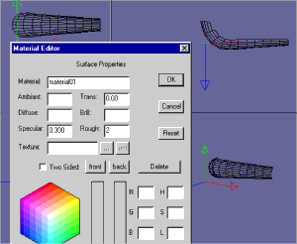
Parameters: Shape - Mainly cylindrical
Transparency - Zero (completely transparent)
Specular
Roughness
Us: Adding volume light to the scene (as a rendering effect)
All the above notes for the glow filter are applicable also to the cylindrical filter. For the shark-scene I used a standard cylinder cut in half along its main axis, diameter 80 units, length 130 units. The Enterprise jet-glow was made with a narrow-angle cone cut in half, with the larger end bent. (See the image)

Ray devices
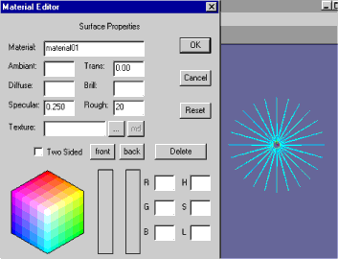
Ray-effect can be obtained at render-time with an arrangement of cylindrical (conic) objects. The material parameters are set to complete transparency and shininess, like for the glow filters. For the candle scene I used a star made by four cylinders of one unit diameter. The ray device for the gloria is an extruded 24-Gon with all the faces peak-extruded (Peak Faces tool). (See the image)
There is plenty of room for experimenting. Take these notes as a starting point for your own "research". I had the idea to use these effects recently and I'm in a rush to share it. If you have already done lighting effects in Anim8or, tell me how.
Have fun,
Laszlo Korosi

